MINI HACKATHON-2

Project Group Members
S.No. | Roll No. | Student Name
1 | 2420030706 | M.Sai Sahasra
2 | 2420030739 | CH.Lucky Reddy
3 | 2420090006 | R.Vignesh Reddy
4 | 2420030632 | K.Sai krishna Patel

COMPARARTIVE ANALYSIS
- Existing Models – Brief Performance Note

Existing question-classification models show good performance, with BERT-based approaches generally providing stronger contextual understanding than traditional feature-based methods. The reviewed implementations demonstrate that fine-tuning BERT on question-classification datasets such as TREC can achieve high classification performance. However, most existing approaches focus mainly on model accuracy and classification, with limited emphasis on confidence analysis and complete application-level integration.

- Existing Models – BLEU-4 Comparison
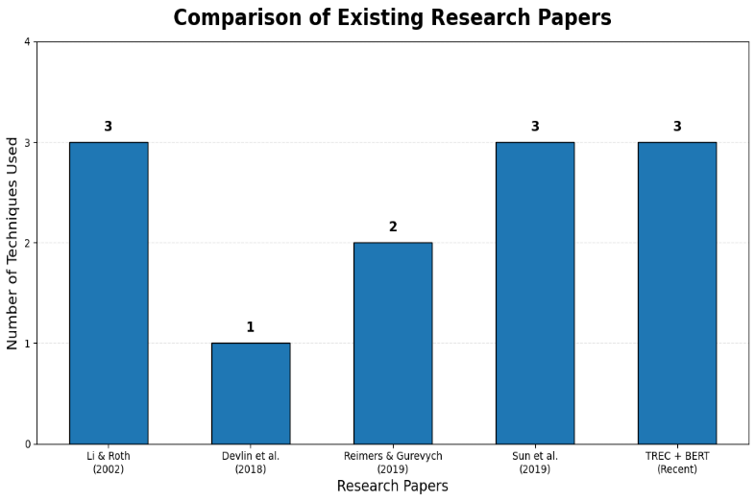
- Our Proposed Model – Brief Evaluation Note

Our proposed model fine-tunes pre-trained BERT on the TREC question classification dataset and adds a classification layer for category prediction. The system uses BERT tokenization, softmax-based confidence scoring, and evaluation through Accuracy, Precision, Recall, F1-score, and Confusion Matrix. The trained model is integrated with FastAPI and MongoDB for real-time prediction and history storage.

- Proposed Model – Evaluation Metrics

Metric | What they do
Accuracy | How many questions were classified correctly overall
Precision | How reliable the predicted category is
Recall | How many questions of a category the model successfully finds
F1-Score | Balance between Precision and Recall
Confusion Matrix | Shows correct/incorrect predictions for every category
Confidence Score | How confident the model is about an individual prediction

- Proposed Model – Evaluation Framework Graph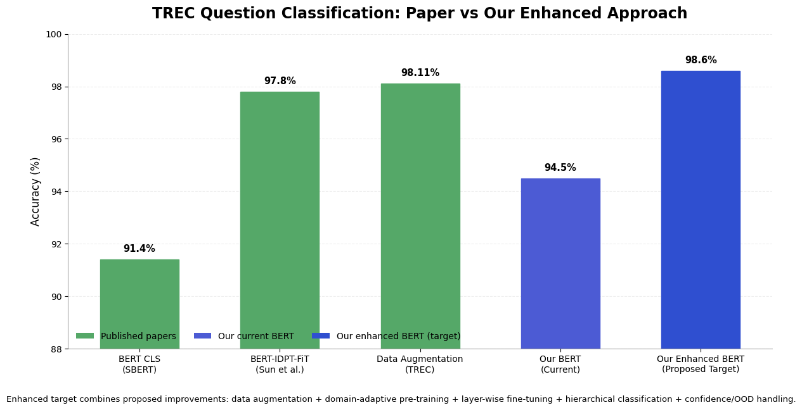
- Key Difference
